**Please insert the requested items in the space provided. Please do not use more than the space provided. If your submission does not adhere to this template, points will be deducted from your assignment.**

***Insert figure here, with border and caption.***

**Figure 1.** A synthetic scheme for chemistry

***Type your first and last name below***

***Hudson Hurtig***

***Insert table of elements with property (K) here, with border, caption and citation.***

**Table 1.** Boiling points for a series of elements1

|  |  |  |
| --- | --- | --- |
| **Element** | **Atomic Number** | **Boiling Point (K)** |
| K | 19 | 1032 |
| Ca | 20 | 1757 |
| Ga | 31 | 2477 |
| Ge | 32 | 3093 |
| As | 33 | 887 |

1Periodic Table, <https://ptable.com> (accessed September 7, 2022).

***Insert table of elements with property and mathematical transformations (from MS-Excel) here, with border, caption and citation.***

***Insert property (K) vs. atomic number graph (direct graph) here, with caption.***

***Insert inverse of property (1/K) vs. atomic number graph (inverse graph) here, with caption.***

***Insert logarithm of property (logK) vs. atomic number graph (logarithmic graph) here, with caption.***

***Insert property (° C) vs. atomic number graph (° C graph) here, with caption.***

***Insert property (° F) vs. atomic number graph (° F graph) here, with caption.***

***Insert graph with property in K, ° C, and ° F vs. atomic number here, with caption.***

**I-1**

**Respond to the following two questions in the space provided.**

1. Make a table like the one below and fill in the values from your graphs.

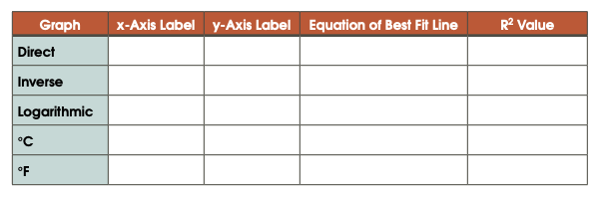

1. Choosing between "Direct", "Inverse", and "Logarithmic"; which has an R2 value closest to 1?
2. Why are the R2 values for the temperature plot in K, °C, and °F the same?

**This is the end of your assignment. You should now save this as a pdf and submit it to Gradescope. Remember to tag pages while submitting to Gradescope.**